Thank you for taking the time to read this, and congratulations on being elected into your roles as executive members of your societies. Societies are the heartbeat of university student life, and none of it would be possible without the time, care, and energy that student leaders dedicate each year.
A good handover is one of the greatest gifts you can give your society. It is an opportunity to reflect on what you have learned, support the next generation of leaders, and ensure that your society continues to grow long after you have stepped down. A strong handover is not about doing everything for the next executive committee, but about equipping them with clarity, confidence, and the freedom to make the role their own.
Handovers are essential to the long-term sustainability of societies. They ensure that the hard work, knowledge, and experience built up over the years continues moving forward, rather than future committees having to start from scratch. Leadership is not just about what you achieve yourself, but about empowering others to achieve even more.
Remember: societies thrive not because of one exceptional committee, but because knowledge, care, and experience are shared and carried forward year after year.
Make your handover count.
All the best,
Tian Liu
Societies Officer (2025/2026)

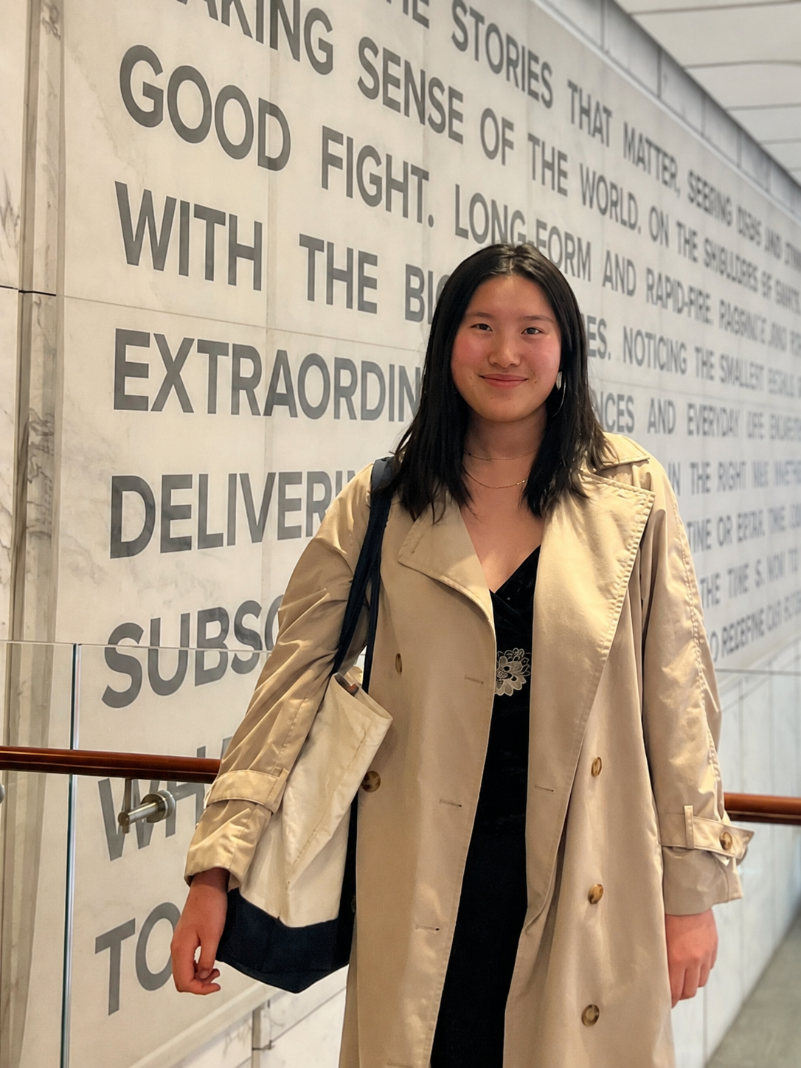

Setting your society up to thrive….
Group registration is an important part of ensuring your society remains compliant and recognised within Durham SU. The process confirms that groups have an active committee structure, appropriate governance in place, and are operating in line with SU policies, insurance, and health & safety requirements.
Completing registration on time also supports a smooth and effective committee handover, ensuring incoming execs have the correct permissions, access to support, and a clear understanding of their responsibilities before the new academic year begins.
A timely and well-managed transition helps groups maintain continuity, plan activity earlier, and place themselves in a stronger position to deliver successful events, engagement, and opportunities for their members.

What is a student group handover?

Think of a handover like passing the baton in a relay race.
It is the moment where responsibility, knowledge, and leadership move from one exec team to the next. Done well; it sets your society up to thrive. Done less effectively; it can create uncertainty, repeated challenges, and a lot of last‑minute messages.
Handover is not just admin – it is leadership development. It can feel daunting, but it is also one of the most rewarding parts of being on exec: you get to invest in future leaders and leave your society stronger than you found it.

Skills required
• Leadership development
• Organisation and planning
• Communication and delegation
• Strategic thinking and continuity
“Knowing what came before gave me a clearer picture of what to do, what to avoid, and what was expected of me — I could hit the ground running instead of starting from scratch” – President of Model United Nations, Lau Lai Sheung

What does a successful handover look like?
1. Starting early
Handover is a process, not a one-off meeting. One of the main reasons handovers become challenging is leaving everything until the last minute.
During the Epiphany term, begin noticing future exec members and give people small responsibilities so they can learn and grow.

2. Running a successful election
Use Durham SU’s election platform. Encourage participation from a wide range of members. Allow sufficient time and ensure fairness by clearly communicating roles and timelines. Support new candidates so roles feel approachable.

3. Share what you have learned
Pass on what worked well, what could be improved, key traditions, contacts, and experiences. Provide a strong foundation while allowing new leaders to shape the role in their own way.

When should you handover?
As early as possible. Completing handover by the end of Epiphany term reduces pressure and gives the new exec time to settle and prepare.
Some societies use a shadow committee, where incoming exec members observe or support the current team during the final term. This can work well, but it’s up to you to decide what fits your society.
Handover timelines vary, but most take 2–6 weeks when done well.
Checklist of what to include
• Role responsibilities
• Documents and shared drives
• Social media passwords
• Contacts
• Templates
• Lessons learned
TIP: If possible, talk through this information in person as well as in writing – it makes a big difference.

How to archive documents and passwords
Organise your society’s materials clearly: event plans, budgets, risk assessments, meeting notes, and login details. Store everything in a shared folder and label clearly.

Who to contact for help?
WHO? | Contact | What for
Societies Officer | su.societies@durham.ac.uk | Collaboration with Group Exec’s & Durham SU
ASK SU | https://www.durhamsu.com/ask | General inquiries, knowledge, resources, support
Community Officer | Su.community@durham.ac.uk | Collaboration with DU
Room Bookings | How Do I Book A Room In The SU Or Elsewhere On Campus? : ASK SU | Room Bookings
Grants | What student group grants are available and how do we apply? : ASK SU | Applying for society grants

Concluding remarks
Designing this handbook has not been a solo project. I would particularly like to thank the former executive members who took part in the focus group to help ensure this handbook is as useful and practical as possible: Lai Sheung Lau, Isabella Skye Towers, Emily Holt, Reuben James Willis, Olivia Hong, Ibrahim Javed, Ming Suen, and Isabella Cheuk.
I would also like to thank Jon, my SU staff support, who has supported me since day one. Thank you for helping make this handover a reality.
Best,
Tian Liu
Societies Officer 2025/2026

