Mixing Desk User Guide

The mixing desk should be used when you would like multiple inputs to simultaneously play through the speaker.

SET-UP

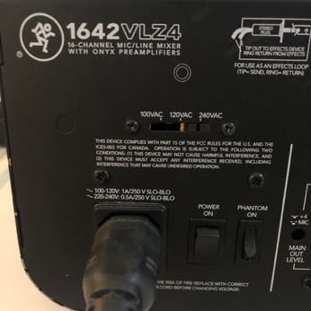
- Place the mixing desk on a table. Ensure it is plugged in and switched on at the wall and back of the mixer.

- Ensure all dials are pointing upwards and the volume faders are down.

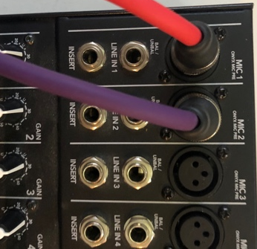
- Plug in your microphone cables into the Mic slots, beginning at MIC 1 and working your way up the channels for each different microphone.

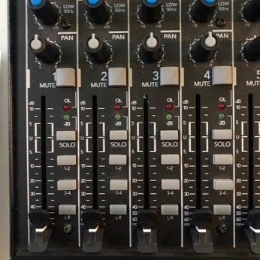
- Plug into the microphone and position them facing away from your speakers. Use each microphone to test that your input is received – you should see a green light flash near the volume fader when the input is received.

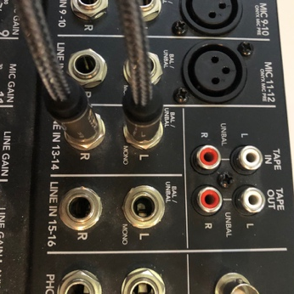
- Plug in the two 1/4” jacks (to 3.5mm jack cable – this is in the ‘cables for mixing desk’ packet) to the LINE IN 13-14, using red for R and white for L.

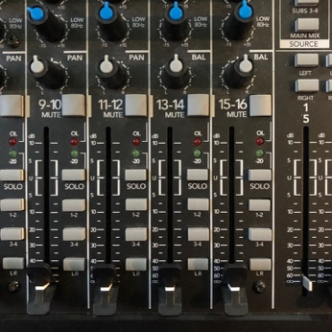
- Plug in the 3.5mm jack at other end of this wire into the headphone jack on your audio device (e.g mobile, laptop, MP3 player). Test that you input is received by playing audio on your device – you should see a green light flash near the volume fader when the input is received.

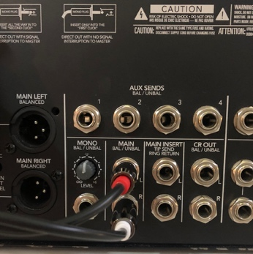
- Plug in the two 1/4” jacks (to dual RCA cable – this is in the ‘mixer to speaker’ packet) to the MAIN on the back of the speaker using red for L and white for R.

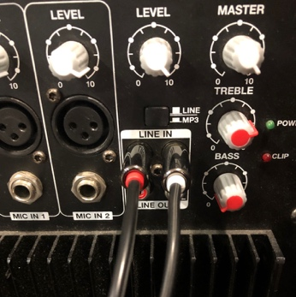
- Plug RCA connectors into the back of the speaker at the LINE IN. Follow the colours of the speaker using red for L and white for R, as coloured on the speaker. Ensure that the button above the cables is clicked out to the LINE position.

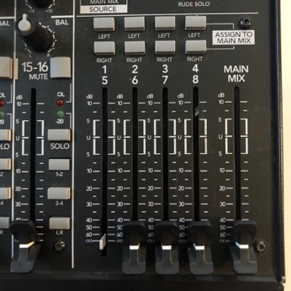
- Switch the speakers on at the wall and bottom of the speaker. Ensure volume is turned up the back of the speaker and then turn up the MAIN MIX volume on the faders at the bottom right to about half way.

- Test each input individually and set each volume and gain.

- Volume for each individual input is controlled by the volume fader in line with the input cable. Ensure the LR button is pressed in before sliding up the volume fader to set an appropriate level.

- Gain increases the sensitivity of signal strength, so a brighter green light near the volume fader will show stronger signal strength. Gain is controlled by the white dial. Be careful when setting your gain as this also increases the pick-up of background / white noise.

- Finally test the mix all together and adjust volumes if necessary.

TO PACK AWAY
- Turn down all volume faders.
- Turn of the speakers.
- Unplug the cable connecting the mixer to the speakers and pack into the mixer cables bag.
- Turn off, then unplug the mixer.
- Unplug the cable connecting the audio device to the mixer and pack into the mixer cables bag.
- Unplug the microphone cables and place microphones back into their case. Neatly fold the microphone wire and return the wire fastening around the cable.
- Reset all dials to the upright position.
- Ensure the cable bag, all microphone cables, microphones and the mixer are returned to SU staff at Reception or Riverside Bar.

MIXER TROUBLESHOOTING

No sound?
- Ensure the speaker is turned on and the switch above the input cable is in the LINE position. Unplug the RCA connectors and re-plug back into the speaker.
- Ensure your audio device volume is turned up and not on mute.
- Ensure the LR button is pressed on the mixer near the volume fader of each input device.
- Ensure all cables are plugged into the correct positions.
- Ensure the gain is turned up.
- Ensure all volume faders are turned up, including the main mix.
- Switch over the 1/4” jack cables plugged into the MAIN at the back of the mixer.

Bad channel?
- Ensure the LR button is pressed on the mixer near the volume fader of the input device.
- Ensure the volume fader is turned up.
- Ensure the gain is turned up.
- Try unplugging the cable and plugging back in again.
- Set it up again in a different channel.

Noise interference?
- Turn the channel faders stereo return dials down one by one. If the sound disappears, check that channel and what it plugged into it.
- If it is microphone feedback, move the microphone away from the speaker.

No power?
- Ensure the wall plug is switched on or move to another wall plug.
- Ensure the power switch is on at the back of the mixer.
- Ensure the power cord is securely plugged in.

