- Motion 1 (the words highlighted in purple indicate the additions we'd like to incorporate.)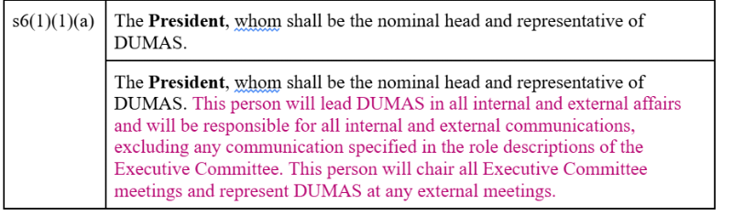
- Motion 2 (the words highlighted in purple indicate the additions we'd like to incorporate.)
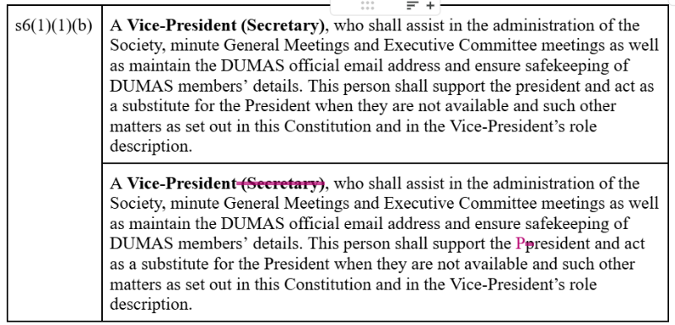
- Motion 3 (the words highlighted in purple indicate the additions we'd like to incorporate.)
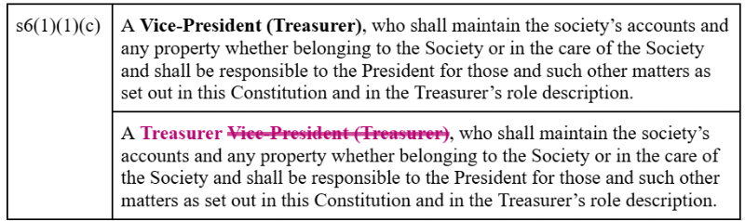

- Motion 4 (the words highlighted in purple indicate the additions we'd like to incorporate.)
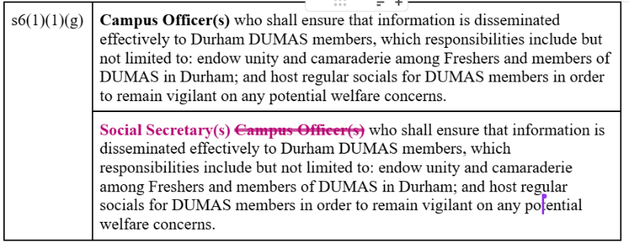
- Motion 5 (the words highlighted in purple indicate the additions we'd like to incorporate.)
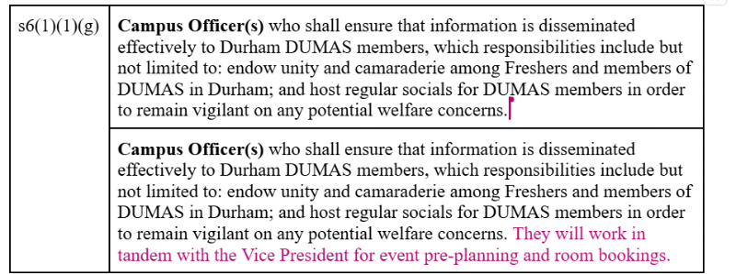
- Motion 6 (the words highlighted in purple indicate the additions we'd like to incorporate.)
